On September 27, 2011 we examined lodgepole pine stands in the Northern Hills of the Black Hills National Forest of South Dakota. The objective was to do a quick assessment of lodgepole pine conditions in the Swede Gulch area (Figure 1). The areas surrounding the stands have seen increasing mountain pine beetle activity in recent years. Lodgepole pine is a rare species in the Forest. With the increased beetle activity, the fate of these stands could be in question.

Figure 1. Location of lodgepole pine stands on the Black Hills National Forest.

Results:
We assessed the 2 larger stands, the eastern one near Buskala Creek and the western one near Tillson Creek. There was significant mountain pine beetle activity in both areas. Both stands contained lodgepole pine considered to be high hazard for mountain pine beetle infestation, with dense stocking (>100 ft²/acre BA) and with a large component (>50% BA) of large diameter (>8 inch DBH) lodgepole pine (Randall et al 2011). In the area near Buskala Creek, most of the surrounding stands of ponderosa pine have or had recent mountain pine beetle attacks. There were very few large lodgepole attacked by beetles. Several individual ponderosa pine were attached that were surrounded by larger diameter yet unattacked lodgepole pine (Figure 2). In the Tillson Creek area, more lodgepole were attacked compared to the Buskala Creek site, but far less than the surrounding ponderosa. We came away with the impression that mountain pine beetle in the Black Hills prefers ponderosa pine over lodgepole. It is unclear if lodgepole will remain relatively beetle free with the current beetle epidemic. As the available ponderosa food source is depleted, lodgepole may be attacked at a higher rate.

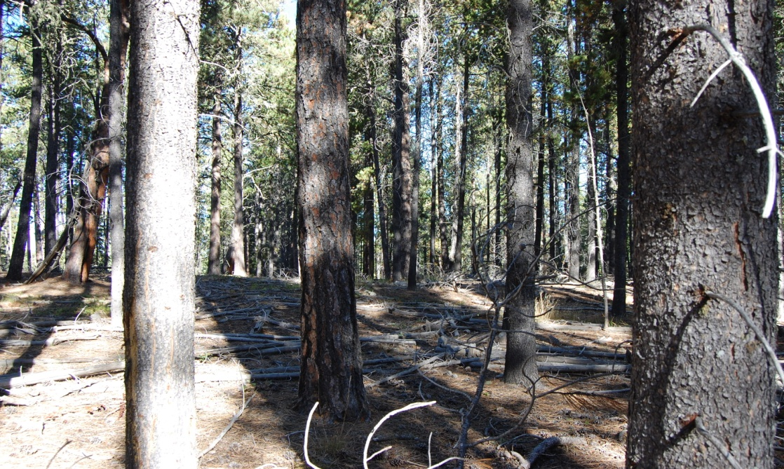
Figure 2. View of ponderosa pine attacked by mountain pine beetle, while surrounding
large lodgepole pines remain unattacked.

While mountain pine beetle in the Black Hills appears to not preferentially select lodgepole, other damage agents are having a larger impact on lodgepole compared to ponderosa. Western gall rust damage was more apparent and damaging on lodgepole pines in these areas compared to ponderosa (Figure 3). Many of the lodgepole had large stem cankers caused by western gall rust, to the point of almost girdling the trees. Western gall rust cankers may not completely girdle trees, but it can still increase the chance of stem break at the rust canker. Increased stem break at the rust canker can be expected as wind increases in the stands due to loss of shelter from the surrounding ponderosa killed by mountain pine beetle. The relatively high rust damage might be due to the genetic composition of the lodgepole pine in the Black Hills. Differences in susceptibility to western gall rust are clear in different seed sources of ponderosa pine.

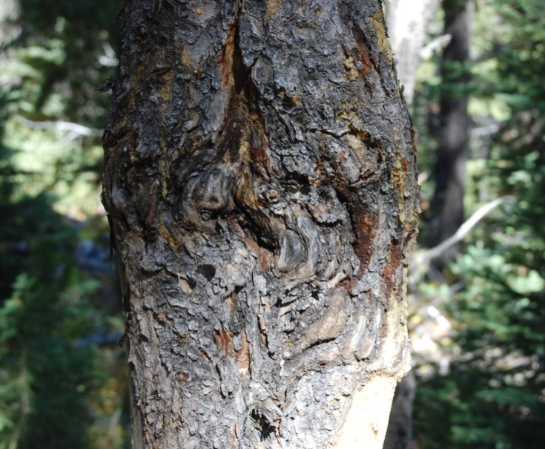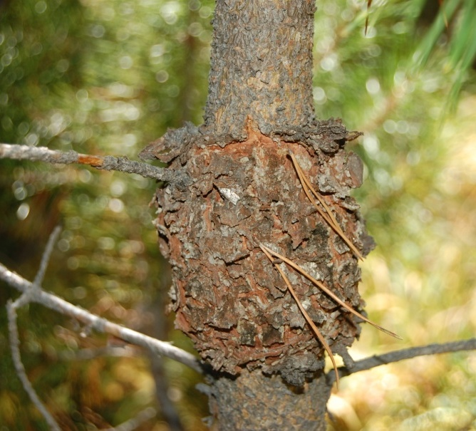
Figure 3. Western gall rust canker on a stem of lodgepole pine tree (left) and girdling a stem of a lodgepole pine sapling (right).

There appeared to be a higher rate of contact and there was more significant animal damage (deer or elk) on lodgepole pine versus ponderosa (Figure 4). Why there is more animal damage on one species compared to another is unknown. The bark is thicker on ponderosa compared to lodgepole, which may mask some damage. However, it appears the animals were preferentially choosing lodgepole.

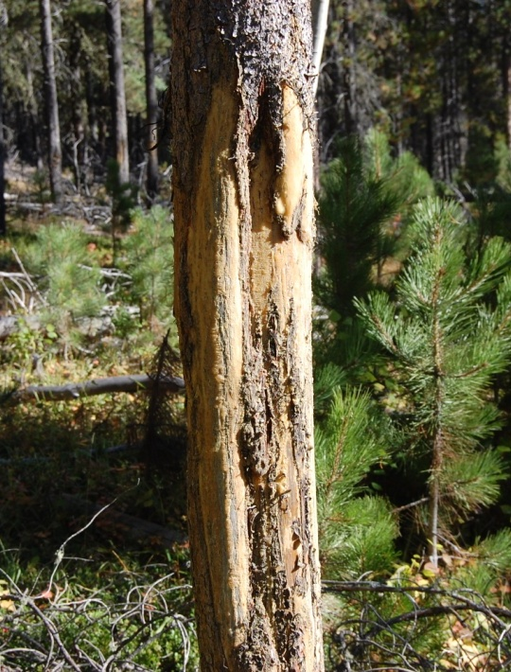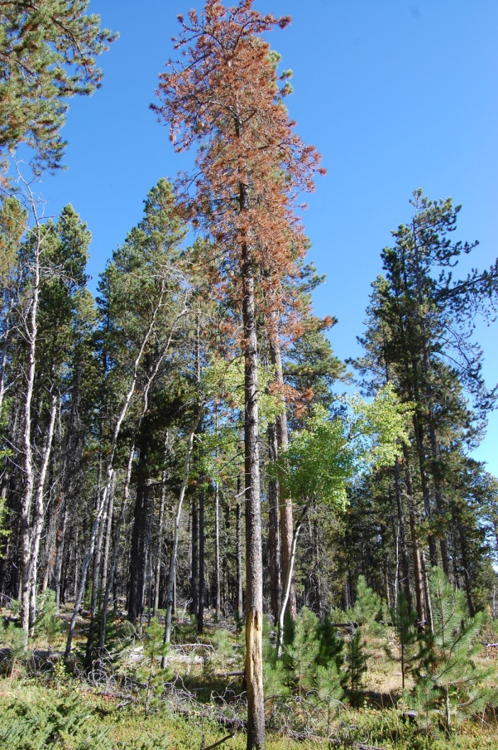
Figure 4. Severe animal damage on stem of a mature lodgepole pine (left), and a lodgepole pine girdled and killed by animal damage (right).

Armillaria root disease was found in the area and is attacking the lodgepole pines. It is commonly found on ponderosa pine throughout the Forest. This disease plays a role in stressing trees, and was causing some unhealthy, thin crowns and killed a small number of trees (Figure 5).
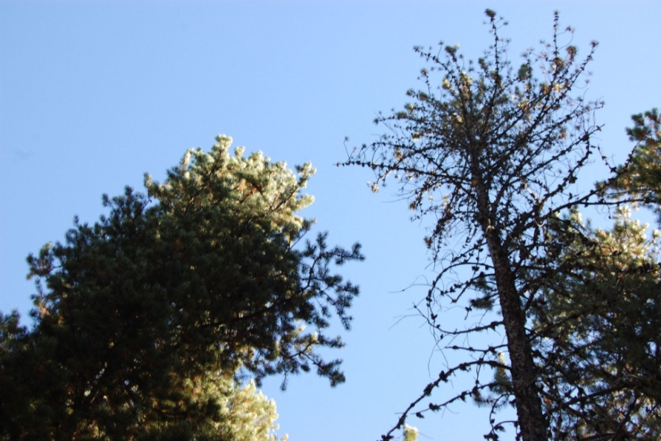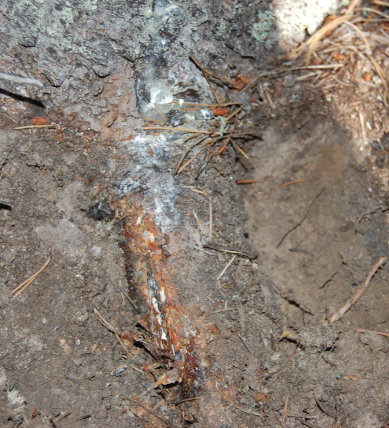
Figure 5. Healthy lodgepole pine crown next to declining crown showing symptoms of Armillaria root disease (left), and resin and mycelial fans of Armillaria on the tree with the declining crown.

Recommendations:
- At present, lodgepole pine is not sustaining the same level of attack from mountain pine beetle as ponderosa pine. Once the ponderosa food source is depleted, this may change. The lodgepole pine stands are in a high beetle hazard state. Options for reducing the hazard include reduced average tree diameter or overall stand density. Neither of these options seem necessary at this point. Individual tree sanitation of the lodgepole pine if they are attacked would be a good strategy. Thinning the surrounding ponderosa pine would have lowered the areas hazard. However, much of the ponderosa has already been killed.
- Western gall rust is present throughout the Forest. There is no silvicultural technique that will reduce infections; heavy infections are often a result of genetics (i.e., seed source). The lodgepole in the Black Hills appear to be very susceptible to this disease, thus infections should be expected to continue. As the stand is opened, increased wind speeds will result in breakage at the larger stem cankers.
- There is no reasonable recourse for dealing with the animal damage. The damage is severe, including to mature lodgepole stems, to the point of killing trees. It is assumed this type of mortality will continue. There is a fair amount of lodgepole regeneration in the stands. Once the stands are opened up, lodgepole pine should at least partially restock the stands.
- Armillaria is found throughout the Forest. It is the least concerning of the damage agents affecting the lodgepole pine at this time, and no treatments are suggested for this disease in the lodgepole pine stands.

References:
Randall, C., B. Steed, R. Bush. 2011. Revised R1 Forest Insect Hazard Rating System User Guide for use with Inventory Data Stored in FSVeg and/or Analyzed with the Forest Vegetation Simulator. Forest Health Protection Report 11-06. Missoula, MT: U.S. Department of Agriculture, Forest Service, Northern Region. 26 p.

