Judicial and
Administrative Review Group
Ecosystem Management Coordination
NFS Litigation Weekly March 30, 2015

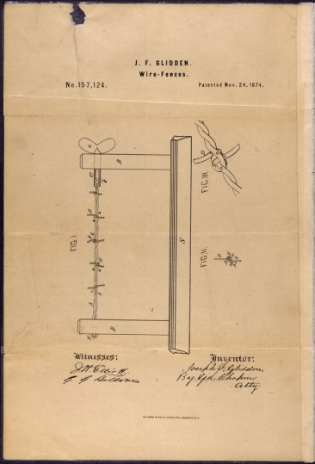

Court Decisions

1. Forest Management │Region 10
District Court Upholds the 2008 Amended Forest Plan and the Big Thorne Project on the Tongass National Forest in Southeast Alaska Conservation Council v. USFS. On March 20, 2015, the United States Court for the District of Alaska ruled in favor of the Forest Service in plaintiffs, Southeast Alaska Conservation Council, Alaska Wilderness League, National Audubon Society, Natural Resources Defense Council, Sierra Club, Cascadia Wildlands, Center for Biological Diversity, Greater Southeast Alaska Conservation Community, Greenpeace, and the Boat Company’s challenge to the Big Thorne Project and the 2008 Amended Tongass National Forest Plan. The court found that: (1) the Forest Service conducted a reasonable assessment of timber market demand (plaintiffs alleged that the Forest Service acted arbitrarily when it relied on outdated projections of timber demand in evaluating the need for the project); (2) the Forest Service did not violate NEPA with regard to wolf population information in its SIR because incomplete and missing current wolf population estimates were identified and explained as to why the information was not considered essential to making a reasoned choice among alternatives; (3) the Forest Service considered the ability to provide sufficient deer habitat to meet both the viability and sustainability of wolf populations, and where that sustainability was not presently possible, appropriately exercised its discretion (plaintiffs argued that the Forest Service violated NFMA by providing an arbitrary explanation on how Big Thorne is consistent with the 2008 Forest Plan with regard to deer habitat); (4) the Forest Service sufficiently disclosed the Project’s impact to wolf populations, specifically that the Forest Service did address differing scientific opinions (plaintiffs claimed that the Forest Service violated NEPA for failure to do so); (5) an SEIS was not required because the Forest Service’s use of a SIR; and (6) that the 2008 Forest Plan did not violate NEPA or NFMA with regard to sustainable wolf populations. (14-00013, D. Ak.)

Update: Plaintiffs filed a notice of appeal of the District Court’s decision on March 26, 2015.

2. Lands │Region 2
District Court Rules in Favor of the Forest Service in Lands Dispute on the San Juan National Forest in USA v. St. Clair. On March 26, 2015, the United States Court for the District of Colorado found that the United States is the owner of a disputed piece of property considered to comprise a portion of the San Juan National Forest. (11-02857, D. Colo.)

Litigation Update

1. NOI │Region 6
NOI Filed Regarding Grazing on the Malheur National Forest. On March 6, 2015, Oregon Natural Desert Association sent an NOI alleging impacts from grazing on the Malheur National Forest in violation of sections 7 and 9 of the ESA (failure to reinitiate consultation and exceeding the amount of incidental take) with regard to bull trout.

New Cases
1. None to Report

Natural Resource Management Decisions Involving Other Agencies

1. None to Report.

